EFFICYCLE 2017

The 8th season of "Efficycle 2017", a student competition by Society of Automotive Engineers Northern India section (SAE-NIS) , was hosted at Lovely Professional University, Jalandhar from 1st-5th November 2017.
Effi-cycle (Efficient-Cycle) is an intercollegiate design competition for engineering students where teams have to design and fabricate energy efficient hybrid-human powered – three wheeled – electric vehicle.
The event is promoted by Society for Automotive Engineering-Northern India Section (SAENIS) and supported by Maruti Suzuki, Indian Oil Corporation and International Centre for Automotive Technology (ICAT). More than 100 Effi-Cycle teams of top engineering institutions from across India competed.
SLIET team “Green Rangers” (nine student members) under the guidance of Faculty Advisor (FA) Dr Shankar Singh, Professor (Mechanical), designed and fabricated a three wheeled hybrid human powered vehicle (FATEH -4; # 51), which has the capacity to act as a good viable option for local transportation.
The SLIET team bagged the Build Quality Award runnerup and Cost Award runnerup, alongwith cash prizes.

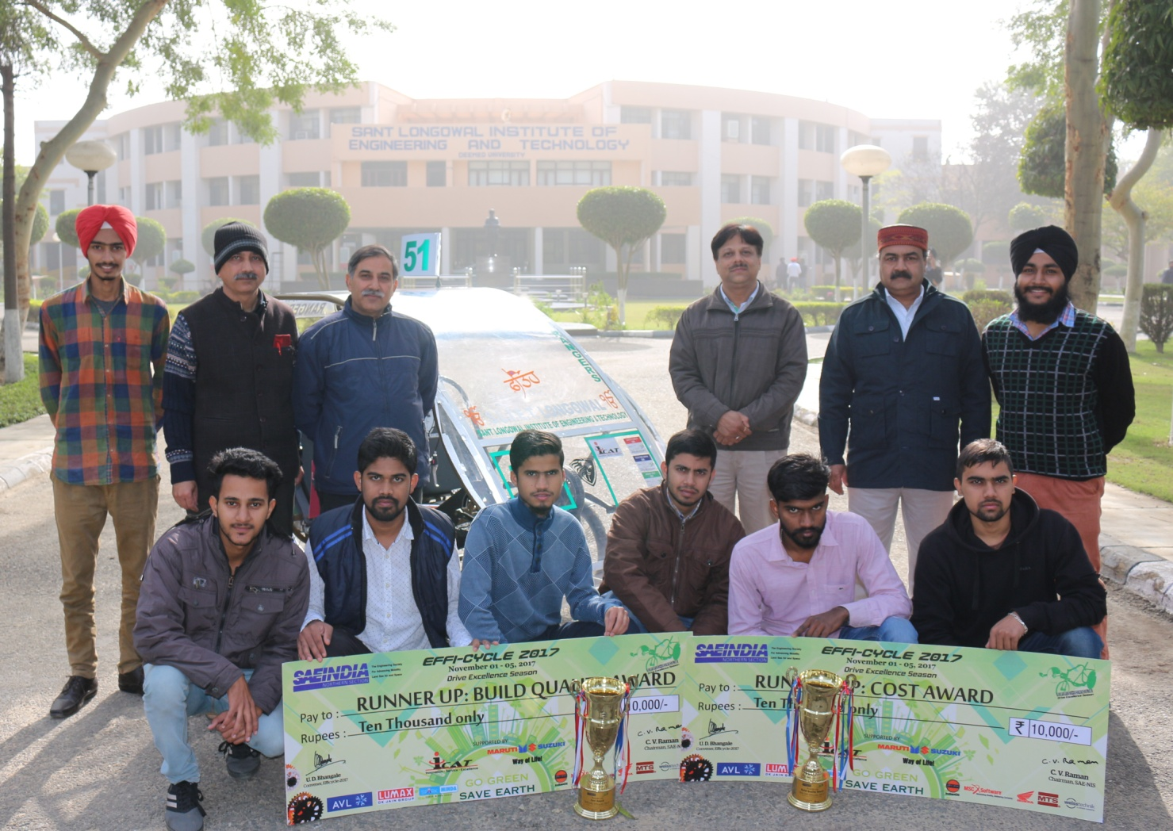
Prof. Shailendra Jain, Director SLIET with Winning team 'GREEN RANGERS' and Faculty Advisor Dr. Shankar Singh. Also present are Prof. A S Arora , Dean (SFW) and Prof. H. Chopra, Registrar, SLIET.
