REPORT

Chairman, BOM, SLIET and Director, SLIET meets Baja SAE India 2018 and Indian Karting Championship bound teams, wish them luck

Mr Dilip Chenoy, Chairman, Board of management (BOM), SLIET and Prof. Shailendra Jain, Director SLIET met the teams ‘Junkyard Warriors’ and ‘ Juggernauts’ and Faculty Advisor Prof. Shankar Singh, and wished them luck.
The teams will represent SLIET at the forthcoming Baja SAE India 2018 (at Pithampur Indore) and Indian Karting Championship (IKC) (at Kolhapur). The student engineers showcased the autonomous vehicle “All Terrain Vehicle (ATV) and GO Kart, respectively.The SLIET team ‘Junkyard Warriors’ and ‘Juggernauts’ have designed and fabricated the two vehicles under the guidance of the Dr. Shankar Singh, Professor (Mechanical Engg.).
Baja SAE India, an automotive engineering competition where college teams vie to build and race the best single-seater four-wheeled all-terrain vehicles (ATVs). The finale will be held at the NATRiP facility at Pithampur near Indore, from January 24-28, 2018, followed by an HR meet on January 29-30, 2018.
The Indian Karting Championship (IKC) will be held at Mohite Racing Academy, Kolhapur (Maharashtra) from 12-15th Jan’ 2018.

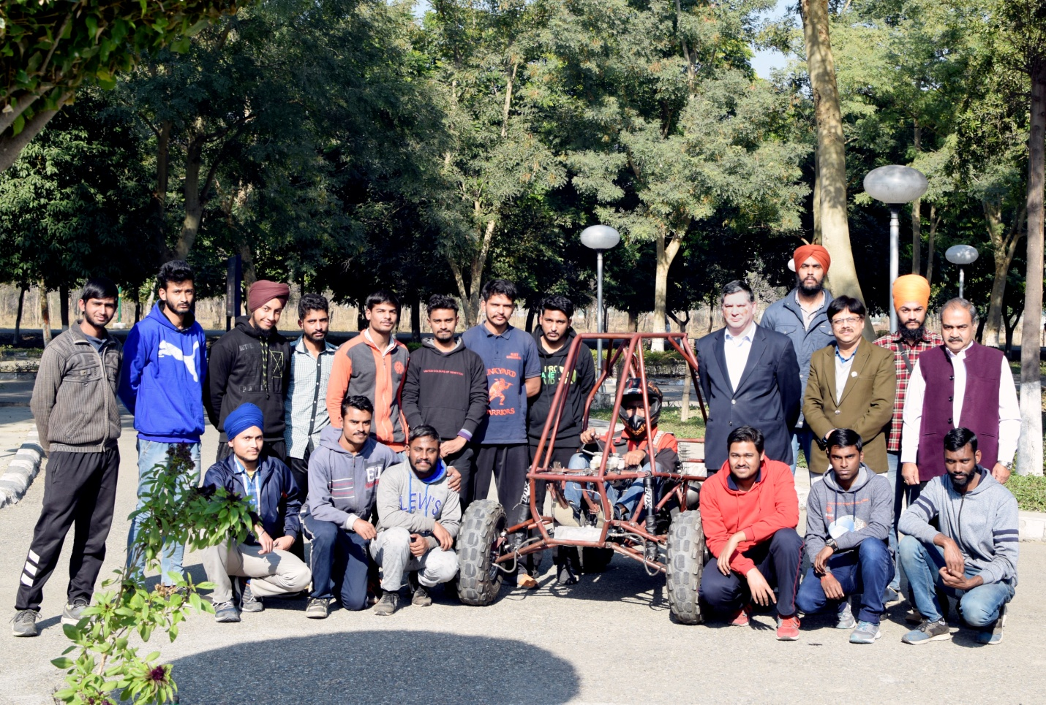
Team ‘Junkyard Warriors’
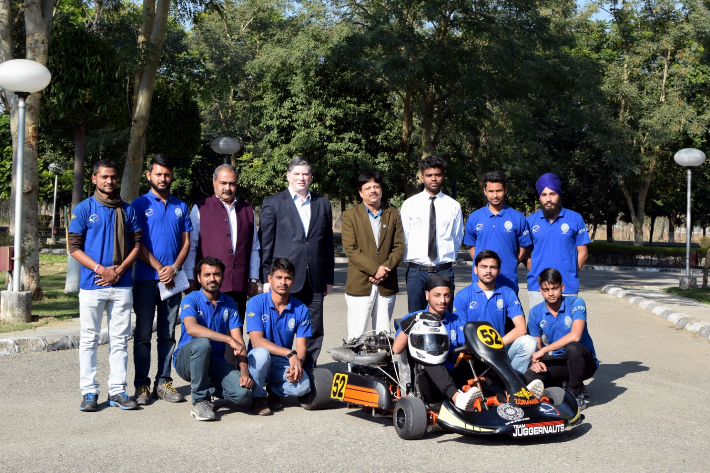
Team ‘Juggernauts ‘

