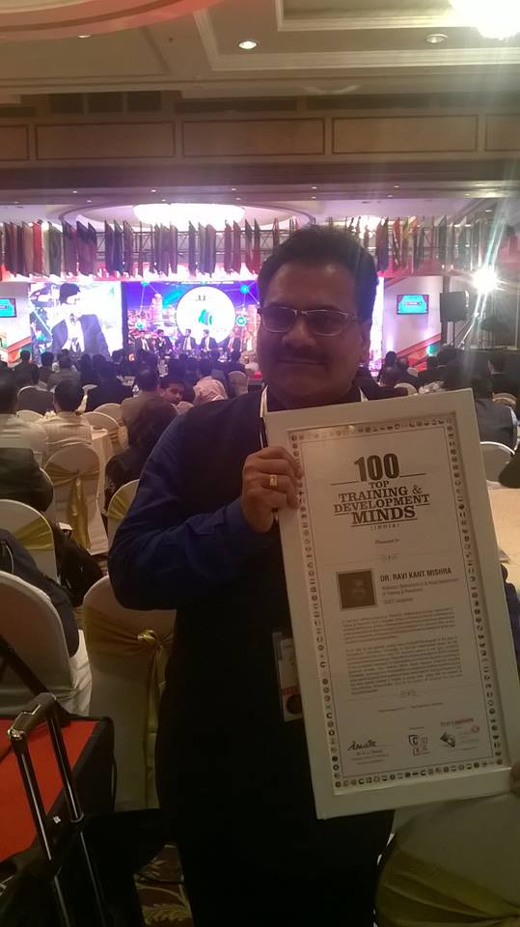
Dr. Ravi Kant Mishra (Professor) Mathematics & Head Department of Training & Placement received the award of “100 top training & development minds” by Times Ascent Group presented in world HRD congress-18” held on 15th February 2018 at Taj Lands End, Mumbai

He was given the award for his continuous contribution in Education Industry to the cater needs of society.

