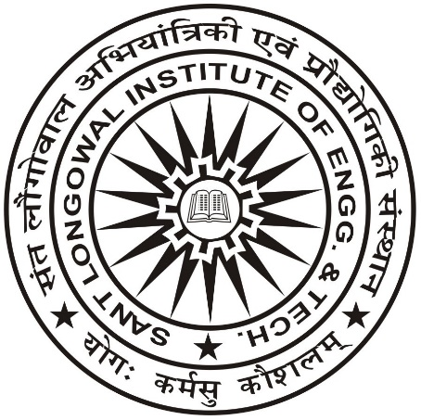 | Go Kart Design Challenge  ‘GKDC 2017’ | 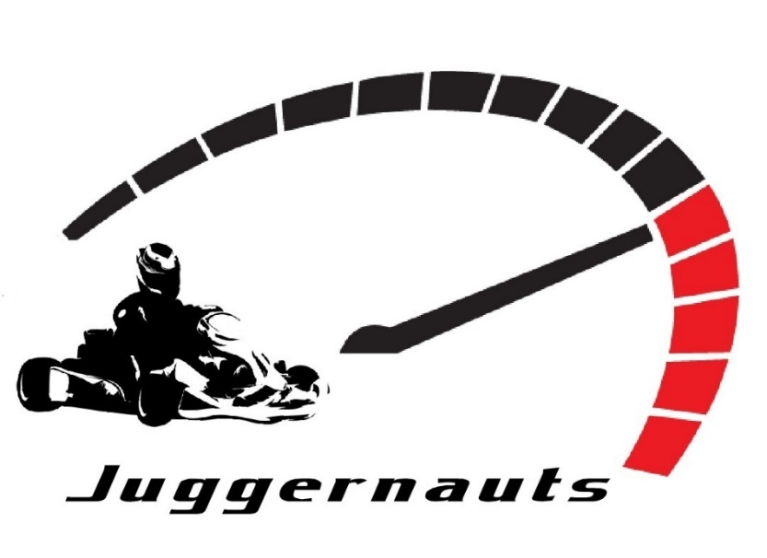
Dt. 18-01-2017
Re: SLIET Team ‘Juggernauts’ Bagged Awards at GKDC 2017

This refers to 4th season of Go Kart Design Challenge (4th GKDC) 2017, a student competition by Indian Society of New Era Engineers (ISNEE), which task engineering students all over India to design and build Go Kart vehicle.
SLIET team ‘JUGGERNAUTS’ comprising of 17 members (of GME & GWT branch and one member of CSE) participated in ‘4th GKDC 2017’, at Kari Motor Speedway, Coimbatore from 14th Jan--17th Jan`2017. The team has designed the Go Kart under the guidance of Prof. Shankar Singh, Faculty Advisor, and qualified the virtual round. The manufacturing of Go-Kart has been done at SLIET itself in Central Workshop/Mechanical Engg deptt.
The SLIET team performed well at their maiden entry and SLIET Go Kart ‘Jorawar’ (Car #150) got the following awards:
- Design Award—Ist
- Aesthetics /Manufacturing Award—Ist
- Endurance Race - 2nd
- OVERALL AWARD WINNER-2nd
Maximum speed attained by our Go Kart in the Endurance race is 95 kmph. Driver Devinderjit Singh (CSE student) was adjudged as Best Driver.
Prize Money Rs 40,000/-.
Team ‘JUGGERNAUTS’ --Ankit Kumar, Captain; Subhash Kr Singla, Vice captain; Dhruvaraj Huparikar, Manager; Devender jit Singh –Driver I; Barjinder Singh- Driver II

Dr. Shankar Singh
Professor (ME)
Faculty Advisor ‘Juggernauts’

Pictures of SLIET Go Kart ‘Jorawar’ (Car #150)
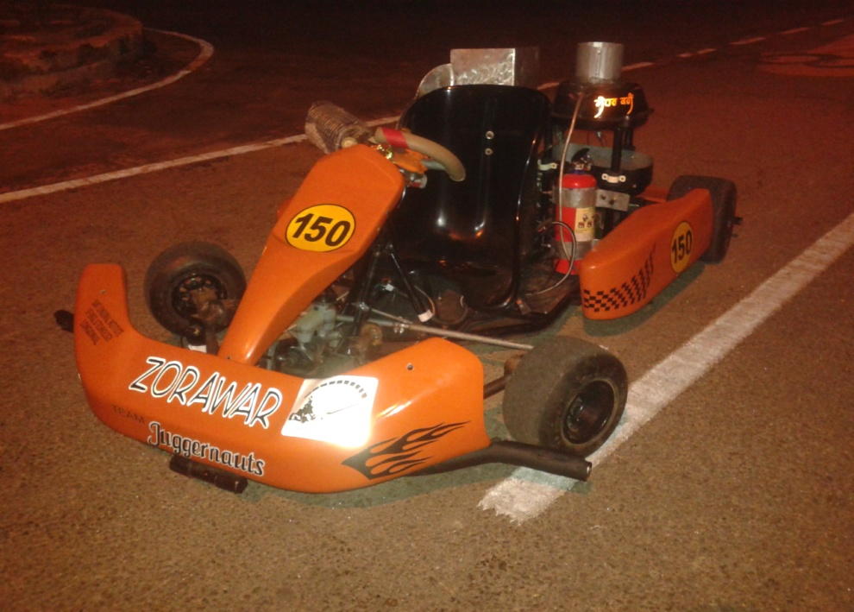
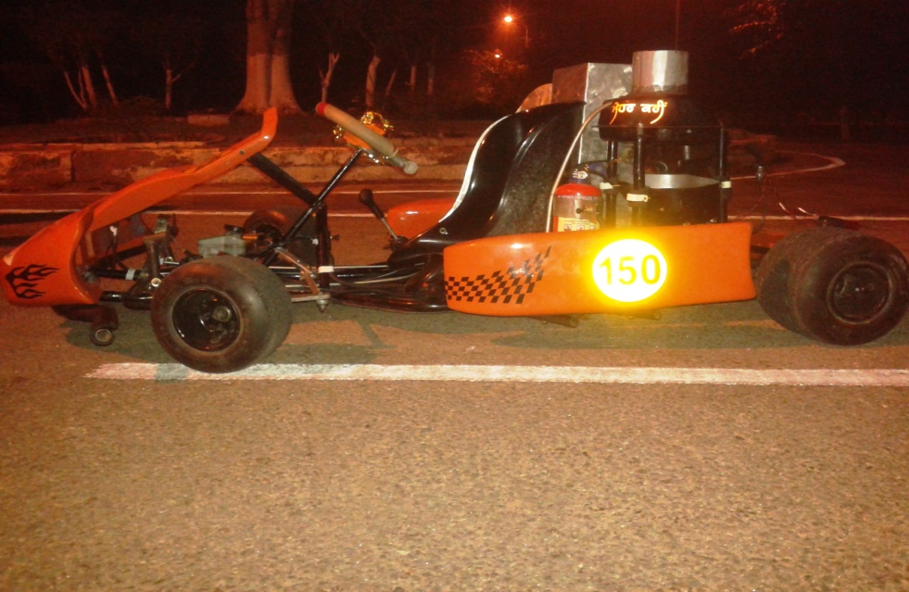
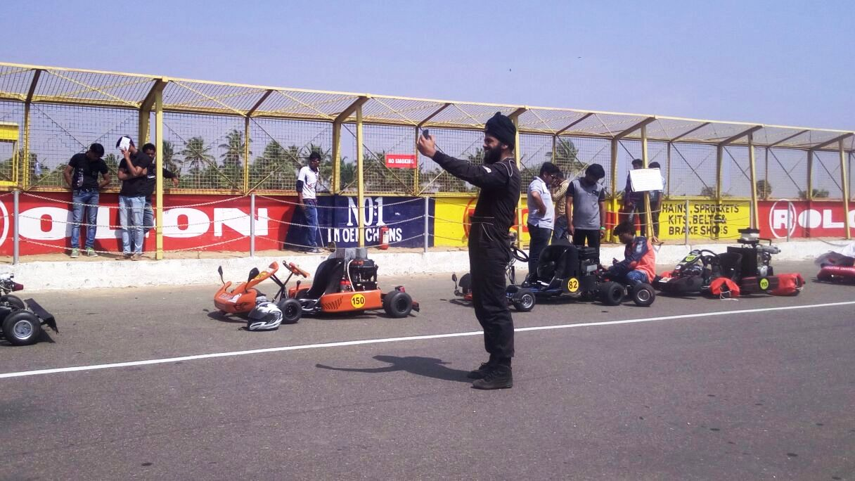

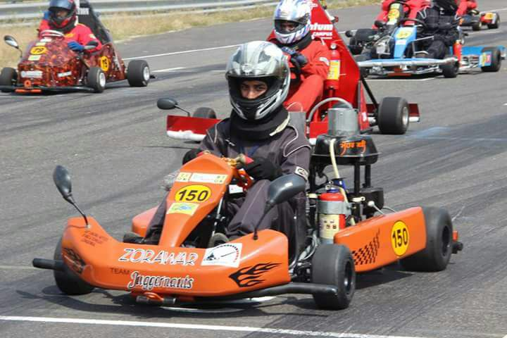
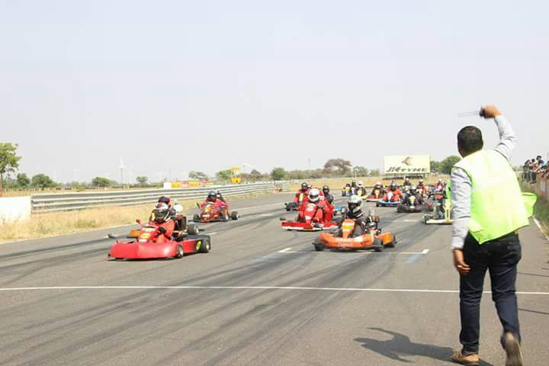 | 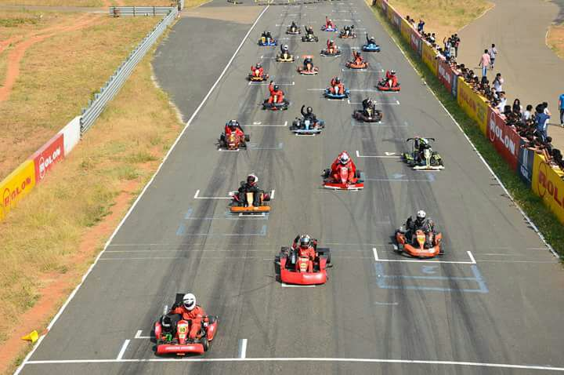
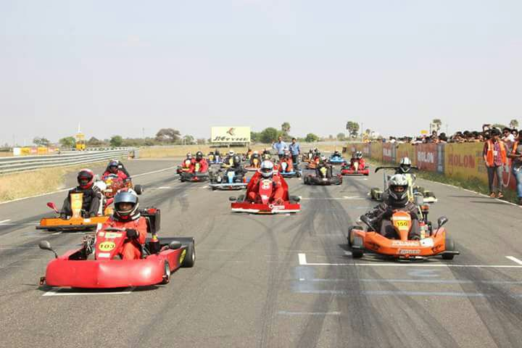 | 